|  |  |  |
| --- | --- | --- |
| **Features** | **RHEL 7** | **RHEL 6** |
| **Default File System** | **XFS** | **EXT4** |
| **Kernel Version** | **3.10.x-x kernel** | **2.6.x-x Kernel** |
| **Kernel Code Name** | **Maipo** | **Santiago** |
| **General Availability Date of First Major Release** | **2014-06-09 (Kernel Version 3.10.0-123)** | **2010-11-09 (Kernel Version 2.6.32-71)** |
| **First Process** | **systemd (process ID 1)** | **init (process ID 1)** |
| **Runlevel** | **runlevels are called as "targets" as shown below:  runlevel0.target -> poweroff.target runlevel1.target -> rescue.target runlevel2.target -> multi-user.target runlevel3.target -> multi-user.target runlevel4.target -> multi-user.target runlevel5.target -> graphical.target runlevel6.target -> reboot.target  /etc/systemd/system/default.target (this by default is linked to the multi-user.target OR graphical.target)** | **Traditional runlevels defined :  runlevel 0 runlevel 1 runlevel 2 runlevel 3 runlevel 4 runlevel 5 runlevel 6  and the default runlevel would be defined in "/etc/inittab" file.** |
| **Host Name Change** | **In Red Hat Enterprise Linux 7, as part of the move to the new init system (systemd), the hostname variable is defined in "/etc/hostname" file.** | **In Red Hat Enterprise Linux 6, the hostname variable was defined in the "/etc/sysconfig/network" configuration file.** |
| **Change In UID Allocation** | **By default a new user created would get UIDs assigned starting from 1000.  This could be changed in "/etc/login.defs" file if required.** | **Default UID assigned to users would start from 500.   This could be changed in "/etc/login.defs" file if required.** |
| **Max Supported File Size** | **Maximum (individual) file size = 500TB  Maximum filesystem size = 500TB   (This maximum file size is only on 64-bit machines. Red Hat Enterprise Linux does not support XFS on 32-bit machines.)** | **Maximum (individual) file size = 16TB  Maximum filesystem size = 16TB   (This maximum file size is based on a 64-bit machine. On a 32-bit machine, the maximum files size is 8TB.)** |
| **File System Check** | **"xfs_repair"   XFS does not run a file system check at boot time.** | **"e2fsck"   File system check would gets executed at boot time.** |
| **Differences Between xfs_repair & e2fsck** | **"xfs_repair"  - Inode and inode blockmap (addressing) checks. - Inode allocation map checks. - Inode size checks. - Directory checks. - Pathname checks. - Link count checks. - Freemap checks. - Super block checks.** | **"e2fsck"  - Inode, block, and size checks.  - Directory structure checks.  - Directory connectivity checks.  - Reference count checks.  - Group summary info checks.** |
| **Difference Between xfs_growfs & resize2fs** | **"xfs_growfs"  xfs_growfs takes mount point as arguments.** | **"resize2fs"  resize2fs takes logical volume name as arguments.** |
| **Change In File System Structure** | **/bin, /sbin, /lib, and /lib64 are now nested under /usr.** | **/bin, /sbin, /lib, and /lib64 are usually under /** |
| **Boot Loader** | **GRUB 2 Supports GPT, additional firmware types, including BIOS, EFI and OpenFirmware. Ability to boot on various file systems (xfs, ext4, ntfs, hfs+, raid, etc)** | **GRUB 0.97** |
| **KDUMP** | **RHEL7 supports kdump on large memory based systems up to 3 TB** | **Kdump doesn’t work properly with large RAM based systems.** |
| **System & Service Manager** | **"Systemd"  systemd is a system and service manager for Linux, and replaces SysV and Upstart used in previous releases of Red Hat Enterprise Linux. systemd is compatible with SysV and Linux Standard Base init scripts.** | **Upstart** |
| **Enable/Start Service** | **For RHEL 7, the systemctl command replaces service and chkconfig.  - Start Service : "systemctl start nfs-server.service".  - Enable Service : To enable the service (example: nfs service ) to start automatically on boot : "systemctl enable nfs-server.service".  Although one can still use the service and chkconfig commands to start/stop and enable/disable services, respectively, they  are not 100% compatible with the RHEL 7 systemctl command** | **Using "service" command and "chkconfig" commands.  - Start Service : "service nfs start" OR "/etc/init.d/nfs start"  - Enable Service : To start with specific runlevel : "chkconfig --level 3 5 nfs on"** |
| **Default Firewall** | **"Firewalld (Dynamic Firewall)"  The built-in configuration is located under the "/usr/lib/firewalld" directory. The configuration that you can customize is under the "/etc/firewalld" directory. It is not possible to use Firewalld and Iptables at the same time. But it is still possible to disable Firewalld and use Iptables as before.** | **Iptables** |
| **Network Bonding** | **"Team Driver"  -/etc/sysconfig/network-scripts/ifcfg-team0 - DEVICE=”team0” - DEVICETYPE=”Team”** | **"Bonding"  -/etc/sysconfig/network-scripts/ifcfg-bond0 - DEVICE=”bond0”** |
| **Network Time Synchronization** | **Using Chrony suite (faster time sync compared with ntpd)** | **Using ntpd** |
| **NFS** | **NFS4.1 NFSv2 is no longer supported. Red Hat Enterprise Linux 7 supports NFSv3, NFSv4.0, and NVSv4.1 clients.** | **NFS4** |
| **Cluster Resource Manager** | **Pacemaker** | **Rgmanager** |
| **Load Balancer Technology** | **Keepalived and HAProxy** | **Piranha** |
| **Desktop/GUI Interface** | **GNOME3 and KDE 4.10** | **GNOME2** |
| **Default Database** | **MariaDB is the default implementation of MySQL in Red Hat Enterprise Linux 7** | **MySQL** |
| **Managing Temporary Files** | **RHEL 7 uses systemd-tmpfiles (more structured, and configurable, method to manage tmp files and directories).** | **Using "tmpwatch"** |

**General Information**

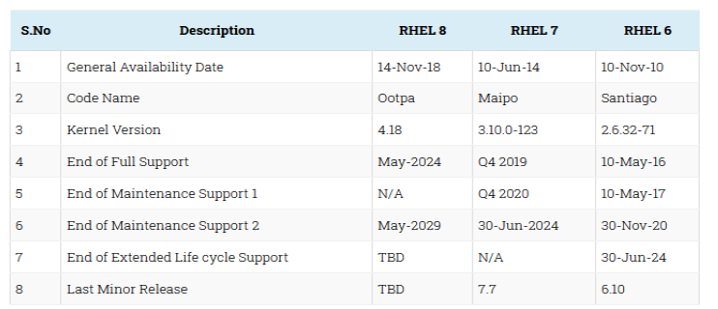

**Boot Process Related Changes**

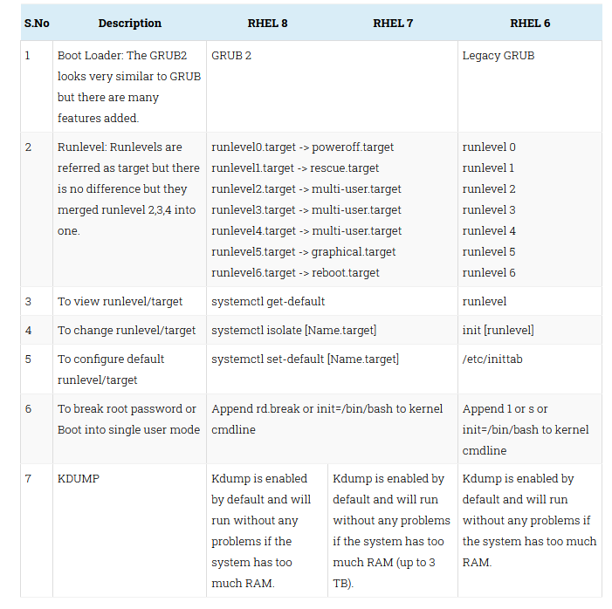

**Major Package Changes**

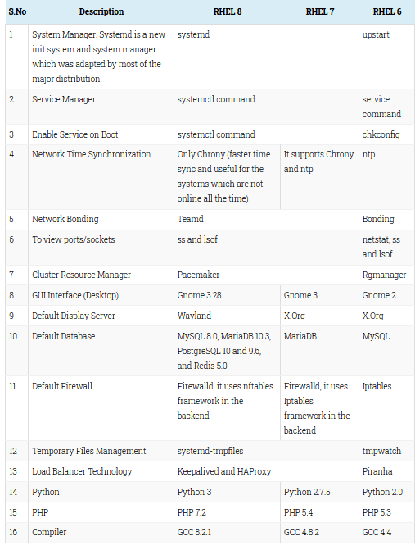

**File System Related Changes**

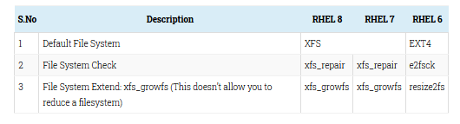

**Other Changes**

